Flexible Mixed-Use Development of a Modern Transit Hub

Katherine Carroll

Prepared as part of a semester-length project for
IDS.332 Engineering Systems Analysis for Design

Fall 2020
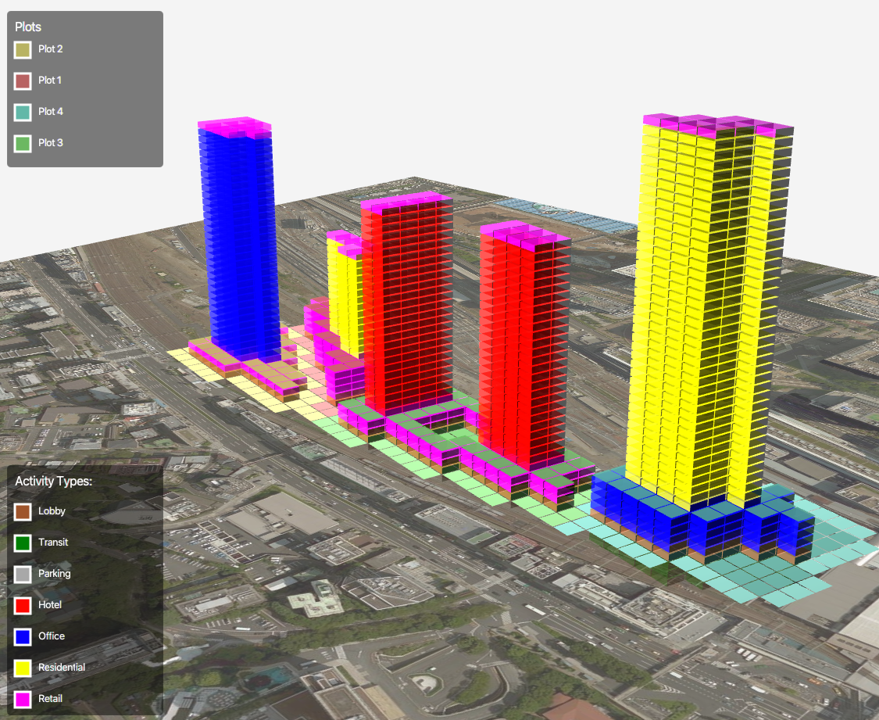



Executive Summary

This report was completed as a semester-long project through Professor Richard de Neufville’s IDS.332 course, Engineering Systems Analysis for Design. In this class, students learn about topics related to flexibility in systems which operate under uncertainty. The course material is intended for those interested in system design and management and focuses primarily on project valuation in different uncertain design scenarios. As a researcher in the Engineering Systems Lab, I am interested in the design of sociotechnical systems that serve many stakeholders. Through my ongoing work on a modeling and simulation project supported by East Japan Railway Company (JR East) to investigate pedestrian mobility in multi-functional transit hub environments, this project investigates a 15-year time horizon over which the site evolves and develops.

The Takanawa Gateway is a developing real-estate project in Tokyo, Japan. It is split into six zones with different dimensions, number of floors, and which serve different functions (like transportation, retail, office, residence, and hotel). Eight uncertainties are identified for this problem ranging from uncertainty in demand growth to changes in market conditions. Evaluating the economic viability of the site is of interest, as is identifying flexible strategies which increase the profitability. An excel-based model is created using a ground-up approach to approximate the Net Present Value (NPV) of the entire site using a Discount Cash Flow (DCF) methodology.

Some important conclusions of the project are that the Takanawa Gateway site is likely to be a profitable investment, and that retail is a major function of the site that should be focused on developing first. Additionally, combining flexibilities is not always advantageous, but as the cost of construction is a more important factor for a longer time-to-build, adding flexibilities is a desired solution for some cases. Finally, future work should be placed on function conversion in addition to phasing decisions to examine how the site will fully evolve given different demand fluctuations.

Acknowledgements

First, I would like to deeply thank Professor Richard de Neufville and Indrayud Biswas Mandal for their constant guidance throughout the course. The generous feedback I received this semester has helped me frame the problem and think critically about flexibility for engineering systems. I would also like to thank the JR East research project team here at MIT, specifically Dr. Olivier de Weck, Dr. Bryan Moser, Dr. Afreen Siddiqi, Kevin McDonough, Keiji Kimura, and Roland de Filippi. I would also like to thank the support of my research project sponsors at the East Japan Railway Company and ongoing feedback from members of the Engineering Systems Lab (ESL) and the Global Teamwork Lab (GTL) at MIT and the University of Tokyo.

Table of Contents
1 Introduction and Motivation 4
2 Problem Context 4
2.1 Connection to Agent-Based Simulation 5
2.2 Mixed-Use Development 7
3 System Model 7
3.1 Reference Architecture 7
3.2 Sourcing Parameter Values from Available Information 8
3.3 Derived Parameters 9
3.4 Uncertain Parameters 9
3.5 Residual Value 11
3.6 Excel Decision Model 11
3.7 Other Model Assumptions 12
3.8 Model Validation 13
4 Base Case 13
4.1 Static Base Case 13
4.2 Uncertainty in the Base Case 14
5 Incorporating Flexibility 18
5.1 Flexibility Options 18
5.2 Flexible Cases 20
5.3 Impact of a 2-Year Time-to-Build 21
5.4 Selecting a Flexibility Strategy 23
6 Limitations and Conclusions 23
6.1 Model Limitations 23
6.2 Ethical Implications 24
6.3 Lessons Learned 24
6.4 Conclusions and Future Work 25
7 Bibliography 25

Introduction and Motivation
Transit hubs are key intermodal transfer facilities at which passengers change between transit services [1]. Modern transit hub environments are intermodal, multi-functional, and provide high throughput of passengers and cargo. With growing interest in smart city planning and transit-oriented development around the world, it is important to relax the boundary of the traditional train station to the transit hub so as to include non-transportation functions such as dining, retail, residence, and others. Some examples of large modern-day transit hubs include:

- London’s Heathrow Airport Terminal 5
- Tokyo’s Shinagawa Train Station
- Paris Gare Montparnasse
- New York’s Penn Station
- Beijing South Railway Station

Each of these hubs have become centers of not only intermodal transfer for transportation, but also host extensive activities of commerce and social interactions.

The Takanawa Gateway Station is a developing railway station in central Tokyo designed and operated by the East Japan Railway Company (JR East). It will serve as a transportation center between Shinagawa and Tamachi stations on the Yamanote Loop Line, which is one of Tokyo’s busiest and most important public transit lines, serving an estimated 4 million passengers daily [1]. The opening of Takanawa Gateway Station was in March 2020, only 10 days before the announcement of the delay of the Tokyo 2020 olympics due to the COVID-19 pandemic.

Surrounding the Takanawa Gateway Station is the Shinagawa Development Project, which has segmented the Takanawa Gateway region into six zones. The first four zones are expected to open in 2024 as the hub of a new city that is designed to link Tokyo with the rest of the world [2]. Zones 5 and 6 are still in early-phase concept design, not slated to open until after 2030. Zones 5 and 6 are located nearest to the current west exit of Shinagawa station. The Takanawa Gateway will deploy new station service equipment, incorporate new environmental conservation technologies, and adopt contemporary retail stores [3]. Additionally, transit-oriented development is at the heart of the Shinagawa Development Project. The key idea is that a substantial population will not only use the Shinagawa-Takanawa-Tamachi area as a transit center but will also choose to reside there. The Takanawa Gateway will link public transit, pedestrian network flows, and urban development altogether.

Problem Context
A problem statement is defined below in order to frame the context of the project. It places emphasis on the importance of flexibility analysis as the critical capability for investigating profitable design alternatives. The problem statement is constructed from the perspective of a real-estate company, like JR East, which would be interested in phasing construction of a large-scale multi-functional transit hub.

Problem Statement
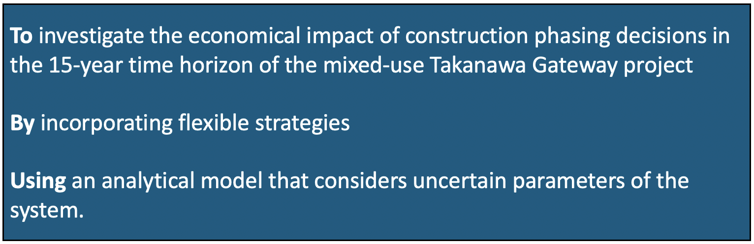

Connection to Agent-Based Simulation
Agent-based modeling and simulation (ABMS) is a technique for simulating complex systems and observing emergent behavior of dynamical systems [5]. The technique focuses on the behavior and rules associated with a specific agent type or set of agent types. ABMS is rooted in discrete-event simulation and can be computationally intensive based on the system parameters and embedded dynamical behavior. It is a powerful tool for investigating emergence, even based on a simple set of agent rules.

The ongoing project with JR East in the ESL and GTL at MIT is centered on developing frameworks for integrated multi-stakeholder ideation, design, simulation, and evaluation of urban transit environments. The basis for the Takanawa Gateway computational model is a developing agent-based simulator. The results of the simulation produce emergent outcomes, such as the engagement of people in different activities on the Takanawa Gateway site. Embedded in the agent are specific human goals – like getting to the train platform on time, or purchasing their groceries at the local grocery store for dinner. However, agents can become distracted or divert from their primary behavior based on the signals they receive around them on the site. Therefore, the outcome of engagement in different activities on the site will be different for each simulation trial given the stochastic nature of ABMS. Through monte-carlo simulation, these engagement scenarios based on the provided functions emerge with some uncertainty around the mean outcome. These uncertainty parameters output from ABMS can then be fed into the flexibility analysis as an uncertainty generator. The set of metrics displayed in Figure 1 are the interface between the agent-based platform and the Excel-based flexibility model used in this project.

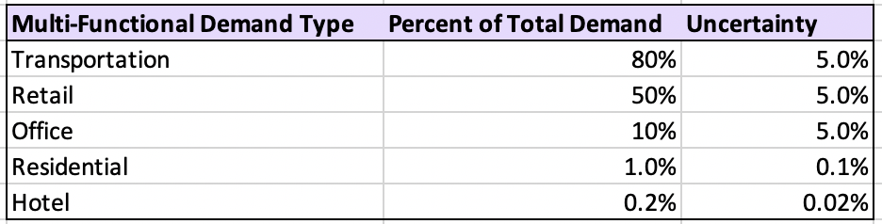
Figure 1: Metrics which interface between the agent-based model (outputs) and excel-based flexibility analysis (inputs).
The values shown in Figure 1 are a single representation of the connection between the agent-based simulation and this flexibility analysis used for the static case. The ‘Percent of Total Demand’ column is the average percentage of all people who enter the Takanawa Gateway site who engage in that specific activity. The ‘Uncertainty’ column represents the standard deviation around the average engagement for that function. When uncertainty is incorporated into the analytical model, the realized demand for that function is computed as the average percentage plus or minus some random percentage amount within the uncertainty range.

Of note, the numeric results shown in Figure 1 are based off of a developing agent-based simulator and population model for the Takanawa Gateway project. As the population model and simulator continue to undergo validation assessment, the outputs of this simulator may dramatically differ. This has the potential to pose dramatic differences on the functional demand input to the flexibility model.

Model federation is another concern given that two distinct models are relevant for this problem. A depiction of how these models interact with eachother is provided in Figure 2. Here, a Graphical User Interface (GUI) produces a single configuration of a site, referred to henceforth as a decision model. In the case of the Takanawa Gateway site, the decision model consists of how many buildings can be constructed, how many floors each building has, whether there is a podium for each building, and the function(s) for which each building can support. This project uses a pre-defined reference architecture, described in more detail in Section 3.1, as the decision model. The decision model is critical because it feeds the ABMS platform and the flexibility model.

The development and analysis of the flexibility model are the centerpiece of this project.

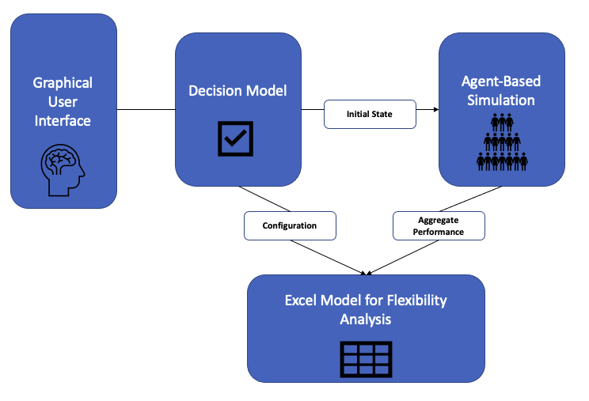
Figure 2: Agent-based simulation feeds flexibility analysis as an uncertainty generator.

Mixed-Use Development
Five functions embedded in the transit hub are included in the system model:
- Transportation
- Retail
- Office
- Residential
- Hotel
These five functions were selected from a longer, more extensive list of functions at transit hubs based on the mixed uses currently incorporated in the agent-based simulator described in Section 2.1. Not included in this model are activities like dining, parking, cultural spaces, healthcare, educational areas, building services, public services, outdoor spaces, specific transportation modes like bikes, scooters, cars, trains, and more.

System Model
A system model was created to investigate the economical impact of construction phasing for this site, as motivated through the problem statement. This sytem model was built in Excel, which provided a robust platform for exploring flexible design scenarios and running monte carlo simulations.

Reference Architecture
The decision model for this system is based on a reference rrchitecture developed in 2015 by JR East for this site. A high-level depiction of the site architecture is shown in Figure 3.
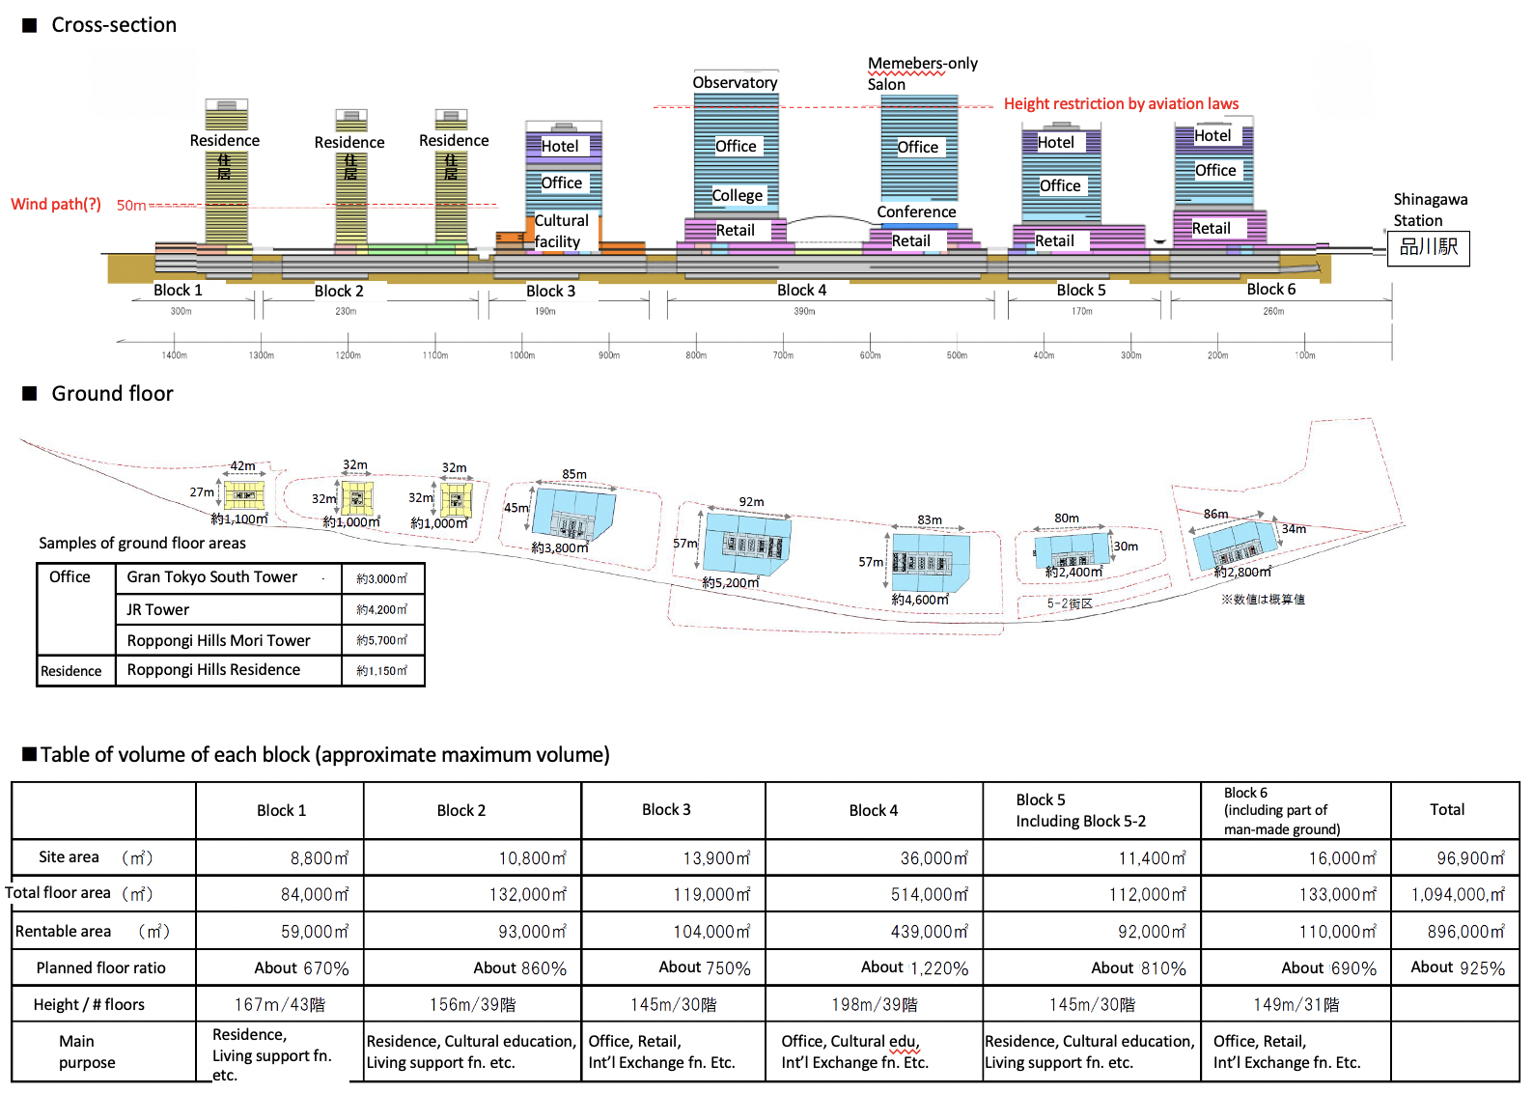
Figure 3: Design Reference Architecture as basis for the system model.
A numeric breakdown of the architecture shown above was created and is shown in Figure 4. The values in this model were directly used to evaluate the capacity for each function on the full site.

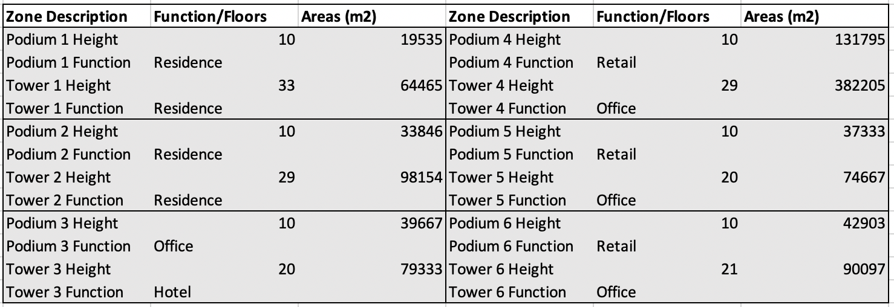
Figure 4: Breakdown of function, number of floors, and area for each Takanawa zone.

Sourcing Parameter Values from Available Information
The parameters for this problem were sourced from online publicly available data. Since profitability of the Takanawa Gateway site has yet to be incorporated as part of the agent-based simulator, these values were collected solely for this flexibility model. A bottom-up approach was taken to estimate the final revenue and capacity metrics for each function. A list of metrics and their associated values is provided in Table 1. Most of the ¥ values are used to determine the approximate revenue generation for each functional activity. For instance, annual transportation revenue is evaluated using Equation 1 below.

$$\begin{aligned}rev_{t}=c_{t}*\min\left(demand\left(t\right),capacity\left(t\right)\right)\#\left(1\right)\end{aligned}$$

Likewise, the spatial values collected in Table 1 are used to estimate the capacity of each building and function.
Table 1: Parameter Summary
Parameter | Variable | Value | Units
Apartment Cost [1] [2] | c_{a} | ¥47,280 | per m2
Average Retail Cost [2] | c_{r} | ¥414,586 | per person
Average Transportation Cost [3] | c_{t} | ¥289,476 | per person
Office Rental (Shinagawa) [4] | c_{o} | ¥11,071 | per m2
Hotel Revenue [6] | c_{h} | ¥25,872 | per user
Land Cost [7] | c_{l} | ¥767,398 | per m2
Construction Cost [8] | c_{c} | ¥211,000 | per m2
Daily trains at Takanawa [9] | t_{d} | 500 | per day
Train capacity (10-car config) [10] | t_{c} | 1518 | people
Retail Person Space Occupancy [11] | k_{r} | 0.5 | m2
Office Person Space Occupancy [12] | k_{o} | 6.612 | m2
Residential Space Occupancy [2] | k_{a} | 100 | m2
Average Hotel Occupancy [13] | k_{h} | 83 | m2

Derived Parameters
Some parameters – like the annual total demand growth – were derived from relevant data. Shinagawa Station is a neighboring station to the Takanawa Gateway station on the highly-trafficked Yamanote line in Tokyo, Japan. Given its proximity and similar passenger use, similar transportation demand is utilized for the Takanawa Gateway site. As shown in Figure 5, the data follows a relatively linear trendline for the 17-year period of analysis. This produces an average annual percent in demand change of 2.36%. An equivalent linearly increasing demand is assumed for the Takanawa Gateway project with a 10% volatility to model uncertainty in total demand.

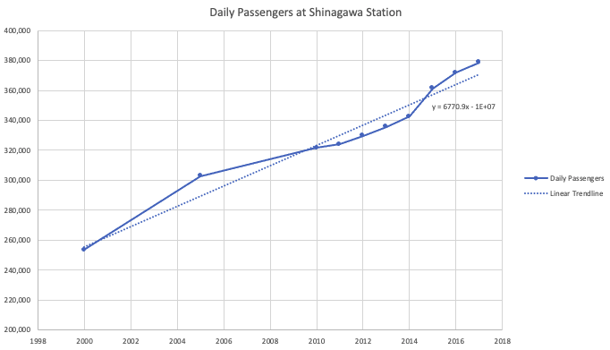
Figure 5: Transportation demand forecast based on empirical data of Shinagawa Station [14].

Uncertain Parameters
Four predominant sources of uncertainty are identified in the system model. These variables serve as the basis for differentiation between the deterministic and probabilistic models. When successfully incorporated in the model, monte carlo simulation should produce an outcome that is representative of the uncertainty distribution.
- Total demand growth projection – This variable represents the total number of people who enter the Takanawa gateway site per day. The number is extrapolated to generate annual revenues based on this total daily demand. Additionaly, specific function demand is computed as a percentage of the total demand. A significant increase in demand might arise when functions of the transit hub are in high demand, with annual population growth, or greater community activity on the site. Conversely, a decrease in demand could be a result of large-scale economic decline, reduced public space use, and competitive nearby development of existing functions on the site. Since total demand directly correlates to the functional revenue and capacity on the site, it is a very important uncertainty parameter to consider.
- Functional demand utilization – These are five uncertainy parameters that are structured in the same format. In a fully connected system, these are the inputs from the agent-based simulation, as discussed in Section 2.1, which provide the percent utilization of total demand for each function on the site (transportation, retail, office, residence, and hotel). In a single year, demand for transporation may dramatically increase whereas demand for hotel may stagnate or decline. These conflicting behaviors are possible for all uses of the site, and therefore the uncertainty is generated independently.
- Cost of construction – Construction cost is a variable that is used to determine the annual expenses based on the number and size of buildings constructed in that year. The price for construction processes is likely to vary over time, although it is probable that the construction cost volatility is less than that of the real estate prices [20]. The variability in this parameter largely reflects the contruction market, which varies on an annual basis. The uncertainty in the cost of construction also aligns with the cyclicality of the real estate market itself. While large cycles of the real estate market last somewhere between 15 to 20 years, smaller cycles occur intermediately which are witnessed through fluctuations in price of construction, rent, value of land, and other factors.
- Retail revenue per person – Given the bottom-up revenue approach and that next to transportation, retail is the function in highest demand at the site, it is important to estimate the amount of money people spend on retail. This is a challenge because people that access the site have drastically different gross and expendable incomes and have seasonal and schedule dependency on their spending habits. It is possible that certain years – for instance, during an influx of population for the Olympic events – the distribution of people who access the site is shifted towards greater expenditure. A study on commercial spending in airport terminals found a large variation in average spending per passenger [8]. Therefore, it is important to reflect this randomness in the model itself.

The above uncertainties were incorporated in the model as random probability distributions around a specified mean value. The numeric mean and volatility for each uncertainty is summarized in Table 2.

Table 2: Summary of mean values and volatility ranges for each uncertain parameter.
Uncertain Parameter | Mean Value | Volatility | Rationale
Total demand growth projection | 2.36% | 10% | The total population demand for the site should increase over time, as is shown for the neaby Shinagawa Station. This is why the linear demand growth of 2.36% is assumed, while also considering a large volatility to reach the realized demand.
Transportation utilization | 80% | 5% | As a transit hub, most people who come to the Takanawa Gateway site will be seeking a mode of transportation. This is an output of the stochastic agent-based simulator and therefore has embedded uncertainty.
Retail utilization | 50% | 5% | Retail is a highly-demanded function of transit hubs. This is an output of the stochastic agent-based simulator and therefore has embedded uncertainty.
Office utilization | 10% | 5% | Leasing office space is another source of revenue for JR East, but only a fraction of the total people who come to the site will actually remain to work there. This is an output of the stochastic agent-based simulator and therefore has embedded uncertainty.
Residential utilization | 1.0% | 0.1% | A small fraction of the population will also reside on the site in the space allocated for new residences. This is an output of the stochastic agent-based simulator and therefore has embedded uncertainty.
Hotel | 0.2% | 0.02% | Even smaller than the number of people residing on the site are the number of visitors needing a hotel. This is an output of the stochastic agent-based simulator and therefore has embedded uncertainty.
Construction cost per m2 | ¥211,000 | 30% | Given that material and labor costs fluctuate and new construction techniques are continuously being developed, the cost of construction fluctuates each year. The cost of construction often follows the cyclicle nature of the real estate market, thus providing a moderate volatility around the mean cost.
Annual retail revenue per person | ¥414,586 | [¥60,403,  ¥768,768] | People have wide fluctuations in spending habits given personal preferences, seasonal dependencies, expendable income, and other factors. Therefore, a large uncertainty in retail revenue per person should be incorporated into the model. These values are based on retail expenditure habits of passengers in airport terminals [8].

Residual Value
For certain applications, like that of real estate, it is important to account for the value that the project contributes even after the end of the flexibility analysis – in this case, after the 15-year time horizon. Since the Takanawa Gateway site doesn’t simply disappear after 15 years, it does continue to generate revenue and also has recurring costs associated with its existence. The amount that contributes to the total NPV of the site post-analysis is called the residual value [21].

This value is estimated in a three-step approach and implemented in the model as such.
- Estimate the annual level of the continuing net cash flow as the value of the project in its final (15th) year.
- Calculate the capital value of this continuing stream by dividing the cash value of the final (15th) year by the discount rate (10%).
- Add this capital value as an “income” in the final (15th) year.

Excel Decision Model
Given that flexibility with construction phasing is the desired design decision for exploration, the key model decisions are the years in which to build each zone. For the context of this project, the term ‘zones’ are interchangeable with ‘buildings’. As shown in Figure 6, there are six primary decision for the project manager and system designer – the year in which each zone begins construction.

A seventh time-to-build variable is accessible for manipulation between either one or two years to complete. For a project with a one-year time-to-build, the capacity for each function of the zone constructed is available the year after construction begins. For a project with a two-year time-to-build, the capacity does not show up until two years later. In other words, functional revenue cannot begin being collected until the zone is completed, either one or two years after beginning depending on the time-to-build. While a two-year time-to-build delays revenue generation, it also costs less in present-value terms given the advantage of the discount rate. A 1-year time-to-build is assumed for initial analysis. The impact on NPV and flexibility for the 2-year time-to-build is explained further in Section 5.4.

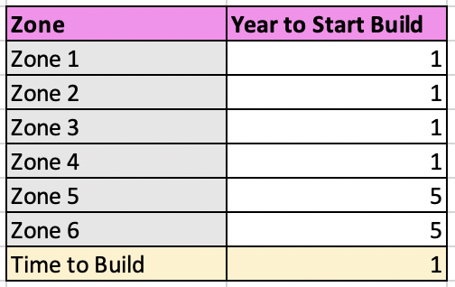
Figure 6: Decisions that a designer can exercise for project phasing including the year to begin construction of each zone as well as how long as specifying the time-to-build.

Other Model Assumptions
For this project, a moderate 10% discount rate was selected since there is always some inherent risk in large-scale projects, although real-estate is a relatively stable investment. Given the current growing interest in transit-oriented develop in Tokyo, a discount rate of 10% seems adequate. A 10% discount rate is also comparable to the 12% discount rate used in the Garage Case as an example of construction expansion.

Regarding the time-to-build variable, construction cost is assumed to only apply for the year that the zone construction starts and is completed. However, the raw cost of construction – being an uncertainty parameter in the model – may differ based on the year that the zone begins and ends construction. Additionally, as mentioned above, the discount rate impacts the net negative construction cost in present value less for the year in which the zone is completed than the year in which construction begins.

Costs regarding maintenance and degredation are also incorporated in this model. These are annual expenditures that represent all the site incurs for maintenance and other recurring issues. A standard 5% of the yearly revenue is estimated for the cost of degredation.

The multi-use functionality of the model also has certain assumptions. For instance, the expenses that each person spends on the site annually – the fourth uncertainty variable – is assumed to contribute fully to actual revenue of the site. This is likely not a realistic assumption, as retailers themselves tend to keep some of the profit, and other recurring costs subtract from the actual amount that people spend on retail. The unrealistic nature of this assumption is offset by the fact that this is an uncertain variable, so the actual profitability of the retail revenue per person each year can be assumed at least in part by the uncertainty range. Another critical assumption of the model is that retail, office, residential, and hotel capacity are all spatially computed. While this tends to make sense for the capacity of offices, hotels, and residences, measuring retail capacity as a spatial quantity is less-intutive and may vary based on the community values, time of day, and personal preferences. A more representative quantity for retail capacity would likely be a per-item-demanded capacity (such as cups of coffee, bento boxes, tubes of toothpaste, etc), although this granularity is not captured in the model. A final assumption that each residence accommodates, on average, 2 people is part of the capacity for residential space calculation.

Model Validation
An intial comparison to the JR East Group Report 2020 [22] demonstrates that despite the model assumptions, there are multiple metrics that align well with the expected NPV of the Takanawa Gateway predicted in this model. For instance, Fiscal 2019 conventional revenues from passenger tickets are estimated as ¥1,792.8 billion, and the transportation revenue estimated from the added station is on the order of ¥100 billion annually. This means that the added station would comprise of approximately 5% of JR East’s total transportation revenue, which is likely a high estimate for their over 1,500 stations but lies approximately on the right scale.

Additionally, in 2020 JR East reports 420,000 m² of office buildings leased floor space and 7,974 total hotel guest rooms. The reference architecture for this site – if all six zones are constructed – estimates an additional 586,635 m² of office space and 955 hotel rooms. This would increase the total capacity for JR East office space by 140% and the capacity for JR hotel rooms by 12%. Again, the numbers are of the magnitude that seem reasonable for growth with this new site development.

Base Case
The base case is an important element of the analysis because it serves as a reference to compare with simulation scenarios under uncertainty and with flexibility. The NPV outcome of the base case is assumed to be a desriable outcome given that everything will occur exactly as predicted. Since the world is unpredictable, this is not always the best solution to conform to. The following sections describe the development of a static base case and the development of the model with uncertainty, as well as how flexible strategies are incorporated to take advantage of upside opportunities and limit downside outcomes.

Static Base Case
Ignoring the uncertain variables, the analysis begins with a static base case. The scenario presented is the base development strategy of the project as it currently stands in 2020:
- Build the first four zones (1-4) first, beginning in Year 1
- Build the last two zones (5-6) in Year 5, beginning after construction has already completed for zones 1-4.
- Set the time-to-build as one year.

It is important to note that none of the zones that can be constructed include the ‘transportation’ function, although revenue from transportation begins being collected in Year 1 in the model (see Figure 7). Given that the Takanawa Gateway Station opened in March 2020, transportation revenue is already being collected on the site when the analaysis begins, but not from other functions. This means that it is assumed starting in Year 1 there is a certain revenue stream, after which the functions which are built with the contruction of zones begin collecting revenue.
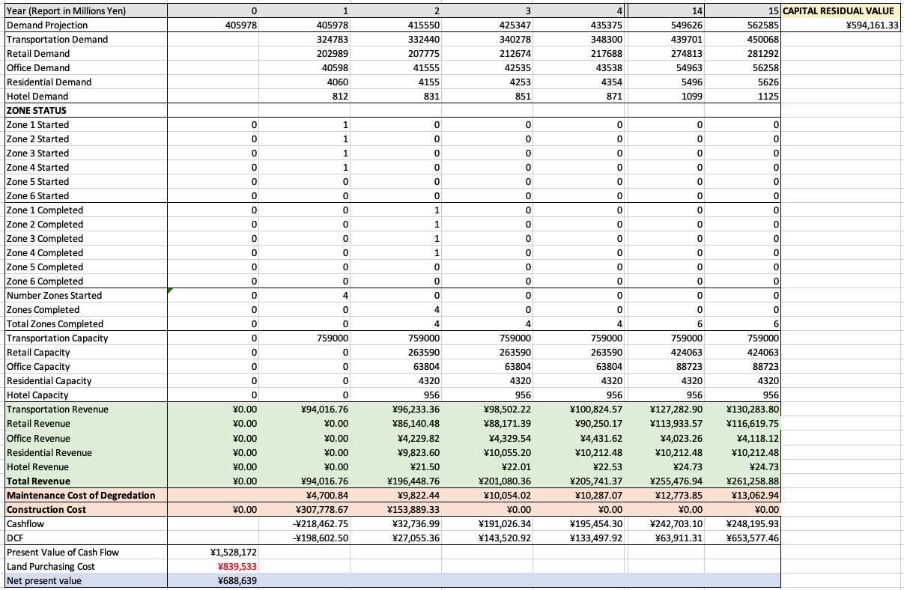
Figure 7: NPV Model with static base case mixed-use developmet decisions. All buildings are constructed by Year 7 with a NPV of around ¥689B.
The results of the static base case demonstrate a net positive NPV of the site. This is promising because given a fixed build scenario determined outside of this model, the NPV is still predicted as ¥698B. It is expected that by taking advantage of strategic build scenarios this NPV could significantly improve.

Uncertainty in the Base Case
Uncertainty is a major factor and it must be considered for monte carlo simulation and to conduct proper flexibility analyses. By incorporating uncertainty into the base case – given the same build scenario outlined in Section 4.1 – outcomes of greater and lesser NPV are observed depending on the scenario.

The first step in understanding uncertainty is in quantifying their impact. A “Tornado Diagram” is contructed using the uncertainty variables and their uncertainty ranges defined in Table 2. The diagram in Figure 8 displays the uncertainties from greatest to least impact from top to bottom based on the Static NPV result. The impact is quantified by varying each parameter one-at-a-time to their extreme values.

For this static case, not many of the demands hit capacity ceilings – this therefore produces a nearly symmetric behavior for some of the variables. However, total demand projection has a slight skew to the negative outcome, and other parameter sensitivities are also shown to be asymmetric. The parameters with the least sensitivity to NPV performance – Residential Demand Percentage and Hotel Demand Percentage – are exploded on the figure and shown to have relatively little impact on the final NPV estimation.

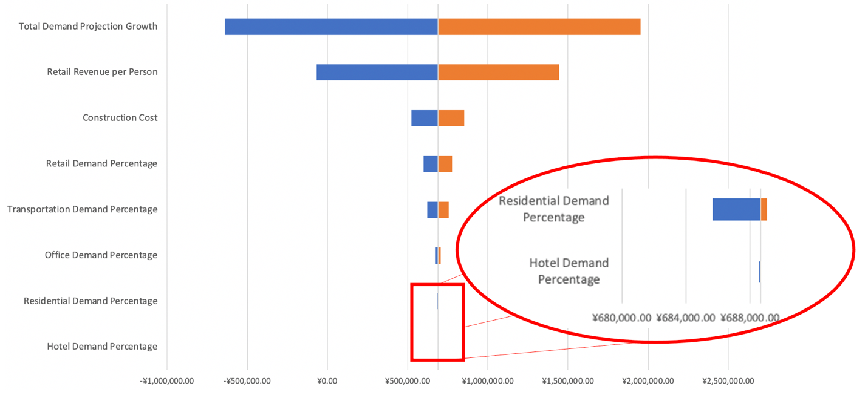
Figure 8: Tornado diagram showing uncertainty impact on Takanawa NPV (in Million ¥ ’20), as compared to the static base case.
The plots shown in Figure 9 demonstrate a possible scenario for one of the Monte Carlo simulation runs where the realized total demand and mixed-use demand values are all uncertain. Figure 10 displays the uncertain market condition parameters and their annual volatility over time. These charts together represent the eight uncertainty inputs to the model, where the Base Case NPV is estimated as ¥548.8B, which is below the Static NPV. Given a different set of uncertainty parameters in a different simulation run, it is possible that the NPV could also jump above the Static NPV result.

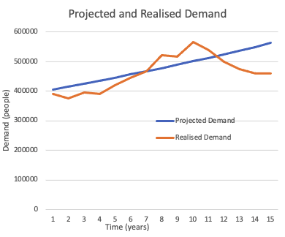 | 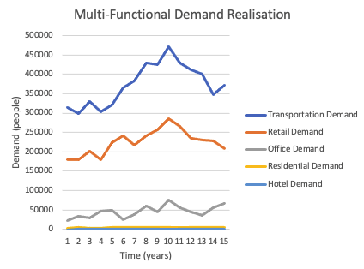
Figure 9: Realized total demand alongside linear projected demand (left) and realized demand for each functional activity (right) for a particular run of the Monte Carlo uncertainty analysis representing a higher NPV ¥548.8B.
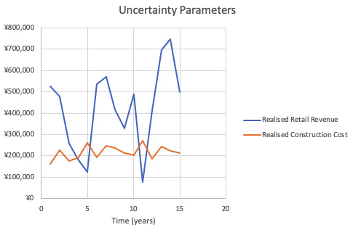
Figure 10: Uncertainty parameters related to market conditions when NPV is ¥548.8B. Note the large cyclical variations over the 15-year time horizon.

The Discount Cash Flow (DCF) NPV analysis for the same monte carlo base case simulation is depicted in Figure 11. The same construction strategy as described for the Static NPV case is used here. Running this 2000 times through monte carlo simulation yields a probabilistic distribution of NPV outcomes, as shown by the target curve in Figure 12. A complement to this analysis is Table 3.
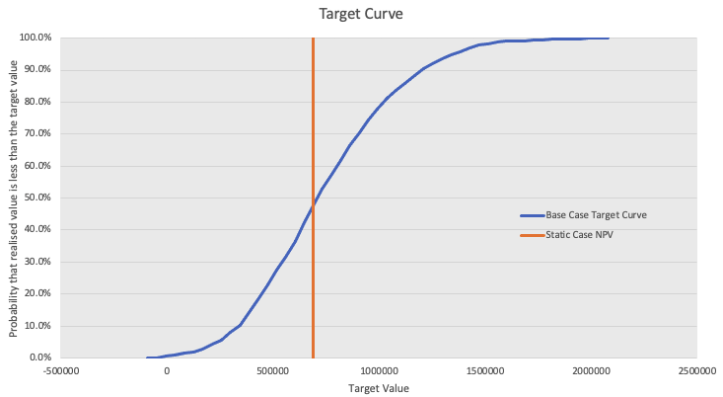
Figure 12: Target curve for the randomized base case, including all sources of uncertainty. Note that the static NPV falls around 50% likelihood for the base case NPV, but this is different than the ‘average’ NPV through simulation.
Table 3: Statistical measures of a specific trial of the randomized base case.
Statistical Parameter | Value,  ¥ Billions
Maximum NPV | ¥1,921
Minimum NPV | (¥135)
Average NPV | ¥739
Value at Risk, P5 | ¥242
Value at Risk, P10 | ¥362
Value at Gain, P90 | ¥1,207
Value at Gain, P95 | ¥1,334

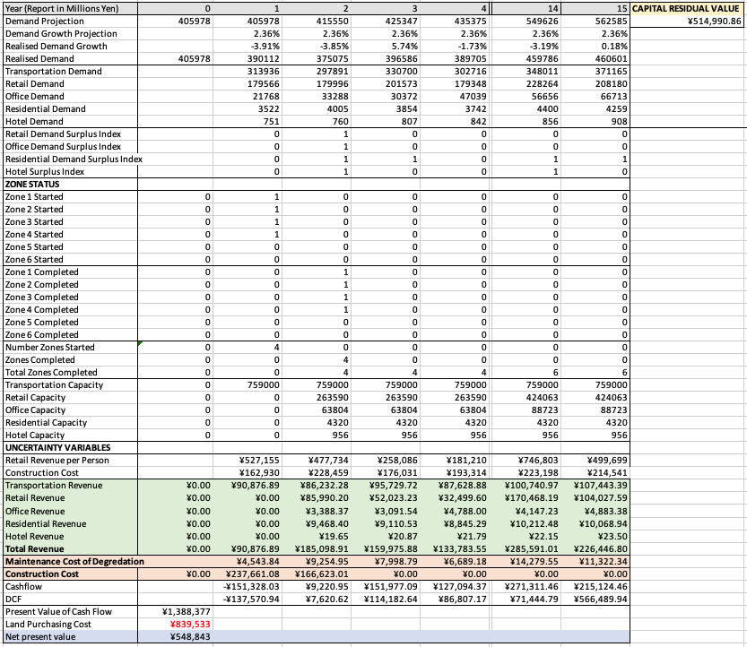
Figure 11: Model screenshot of the NPV analysis for a particular Monte Carlo run when NPV is ¥548.8B (less than the static case). All values represented in millions ¥.

Incorporating Flexibility
As a starting point, the base case with uncertainty suggests that the system under uncertainty can perform both better and worse than the static base case given the scenario parameters. It is prudent to understand which strategies can be employed by either maximizing the upside potential or minimizing the downside loss – in otherwords, by incorporating flexibility.

Flexibility Options
There are many forms of flexibility that are possible for phasing of a construction project, the choice of which largely depend on the realization of the uncertainty parameters for a given scenario. The list provided in Table 4 highlights some possible flexible actions that a designer could investigate for increasing NPV, a few of which are implemented in the flexibility model.
Table 4: Summary of possible flexibility actions in phasing the transit hub.
Flexibility Action | Rationale | Effect of Action
Construction Start Delay | Taking advantage of the discount rate, it may make sense to delay the start of construction to reduce cost of construction in present value. | Maximize Upside
Conditional construction to meet realized mixed-use demand trends | Only build when demand for a certain function reaches some percentage of current capacity. This can be treated as an expansion option– expand the project to construct buildings that contain the demands that reach capacity first. | Maximize Upside
Conditional construction initiation when real estate market conditions are favorable | Given that the cost of construction is a large expense and varies annually, it makes sense to build when construction costs are low. This cannot be ensured for the following years after construction has began, but it can be built in as a flexibility option to only begin construction when the cost is favorable. | Maximize Upside
Constructing retail zones when retail revenue per person is favorable | Since one of the uncertainty parameters is the retail revenue per person – which varies significantly over time – it may make sense to only construct retail when retail revenue is high. | Maximize Upside
Conversion of functions to highly-demanded | Given that the site can support mixed-use development, it may make sense to convert some of the less demanded functions to those which are highly demanded, especially if the demand for those functions continues increasing over time. | Maximize Upside
Conversion of functions to most profitable | Since the different functions have different profitability (for example, hotels are more profitable than residences), it may make sense to convert functions which are not performing well to more profitable functions. | Maximize upside
Abandon portion of project | It may be the case that there is not enough demand to meet the anticipated full supply. In this case, it makes sense to abandon portions of the project. | Minimize downside

For the purposes of this project, where the primary motivation is construction phasing, all conversion flexibility options are disregarded and considered as future work. Another flexibility that is not actually implemented as one of the options in the model is the conditional construction on retail revenue per person. While this is something that seeks investigation in future iterations of the model, the current selection of annual retail revenue per person is a monte carlo sampling of the large distribution range. Unlike cost of construction and total demand growth, which follow suggested patterns of change over time, retail revenue is randomly picked from a large sampling, and therefore it did not seem appropriate to make flexibility decisions based on this variability. In the future, a trend in retail revenue based on historical data should be included, after which a flexibility action will be implemented in the model. Table 5 provides a summary of how four specific flexible actions are implemented in the model.

Table 5: Flexibility Action Implementation in Flexibility Model
Flexibility Action | Implementation in Model | Result
Case 1: Abandon Last 2 Zones if Retail Demand is Not Met | Build zones 1-4  IF(retail demand > 90% retail capacity for 4 YEARS) build zone 5  IF(retail demand > 90% retail capacity for 8 YEARS) build zone 6  ELSE: abandon zones 5 and/or 6 | Only build excess retail in highly demanded scenarios. This reduces the risk of upfront overspending in construction cost.
Case 2: Build Retail First, then Build on Conditional Demand | Build zones 4 and 5  IF(residential demand>90% residential capacity) build zone 1  IF(residential demand> 90% residential capaicity) build zone 2  IF(office demand > 90% office capacity AND hotel demand > 90% hotel capacity) build zone 3  IF(retail demand > 90% retail capacity) build zone 6  ELSE: Abandon zones which were not demanded | Capacity that attempts to follow demand trends
Case 3: Build Retail First, then Build if Low Cost of Construction | Build zones 5-6  IF(cost of construction < mean(cost of construction)) build one building at a time, starting with zone 4 and working in reverse chronological order | Begin construction in times that are favorable for the real estate market.
Case 4: Build Retail First, then Build with Conditional Demand AND Low Cost of Construction (CoC) | Build zones 4-5  IF(residential demand>90% residential capacity AND CoC low ) build zone 1  IF(residential demand> 90% residential capaicity AND CoC low) build zone 2  IF(office demand > 90% office capacity AND hotel demand > 90% hotel capacity AND CoC low) build zone 3  IF(retail demand > 90% retail capacity AND CoC low) build zone 6  ELSE: Abandon zones which were not demanded and year was not low CoC | Construction occurs less than in either Case 2 or Case 3 given the joint conditionality. This reduces construction cost, but conversely may not take advantage of reaping profits from each function if the conditions are not met.

Flexible Cases
Five cases are direcly compared through their target curves, as is demonstrated in Figure 13:
- Base Case: Build first four zones, then build zones and 5 and 6 five years later.
- Flexible Case 1: Build first four zones, then potential abandonment of zones 5 and 6.
  - If retail demand is not realized for zones 5 and 6, do not build.
- Flexibile Case 2: Build retail, then conditional construction to meet functional demands.
  - Start with building zones 4 and 5, then conditionally build all other zones if their function is demanded starting in year 2.
- Flexible Case 3: Build retial, then build when cost of construction is low.
  - Only begin construction cost is below average, as defined in Table 2.
- Flexible Case 4: Build retail, then build with functional demand AND low construction cost.
  - Combining flexible cases 2 and 3 together, only construct zones with realized demand and when there is below-average cost of construction.

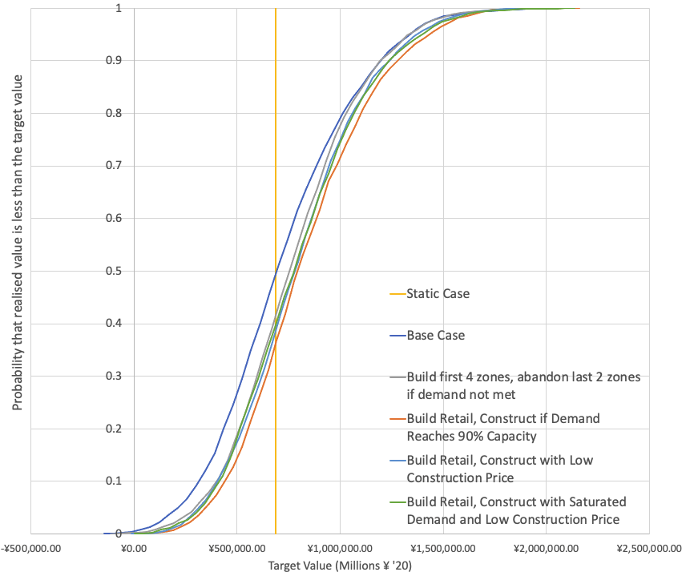
Figure 13: NPV target curves for each flexible case with one-year time-to-build.

Table 6: Statistical parameters for each flexibility case investigated; most advantageous case for each metric is highlighted in green.
Statistical Parameter  (Results in Billion ¥) | Base Case | Build first four zones, abandon last 2 zones if demand not met | Build retail first, construct if demand reaches 90% capacity | Build retail first, construct with low cost of construction | Build retail first, construct with saturated demand and low construction price
Maximum NPV | ¥1,921 | ¥2,001 | ¥2,225 | ¥2,059 | ¥1,972
Minimum NPV | (¥135) | (¥20) | (¥314) | (¥49) | (¥52)
Average NPV | ¥739 | ¥792 | ¥832 | ¥800 | ¥814
Value at Risk, P5 | ¥242 | ¥310 | ¥337 | ¥295 | ¥320
Value at Risk, P10 | ¥362 | ¥392 | ¥429 | ¥381 | ¥403
Value at Gain, P90 | ¥1,207 | ¥1,218 | ¥1,258 | ¥1,242 | ¥1,270
Value at Gain, P95 | ¥1,334 | ¥1,342 | ¥1,442 | ¥1,414 | ¥1,394

Reviewing the results of the flexibility analysis numerically, it is evident in Table 6 that Flexible Case 2, or the option for beginning construction with retail and constructing new zones if the functional demand reaches 90% capacity of the previous year, performs very well across each statistical outcomes (highlighted in green). However, for extremely risk-averse decision-makers, it may be desired to choose a different scenario that has a larger minimum NPV. While all scenarios produce an outcome where the minimum possible NPV is negative, the net negative is recovered by 5% at the Value at Risk. Therefore, bank loaners or other financial investors who are so risk averse that they cannot accept up to a 5% chance of net negative outcome may seek other options. The abandonment option, which seeks to minimize the downside of the project, for example, only has net negative results up to 0.2% of cases.

Impact of a 2-Year Time-to-Build
Since a one-year time-to-build was assumed for the initial set of Monte Carlo trials, a desired study is to investigate the impact that longer periods of construction have on site NPV. Specifically, a 2-year time-to-build was implemented to see how the flexible cases adapted to this new variable.

As can be seen in Figure 14 and is numerically summarized in Table 7, the average NPV for each flexible case reduces in comparison to the 1-year time-to-build. This shifts all of the target curves to the left. Of particular interest is the advantageous nature of the cases which take advantage of low construction costs. This behavior is consistent with expections, given that longer time-to-build determines that profit cannot be collected until a later year once the construction has completed, thus reducing the average NPV. Therefore, building when the cost of construction is favorable is even more essential given that reaping profit from the site development is delayed.
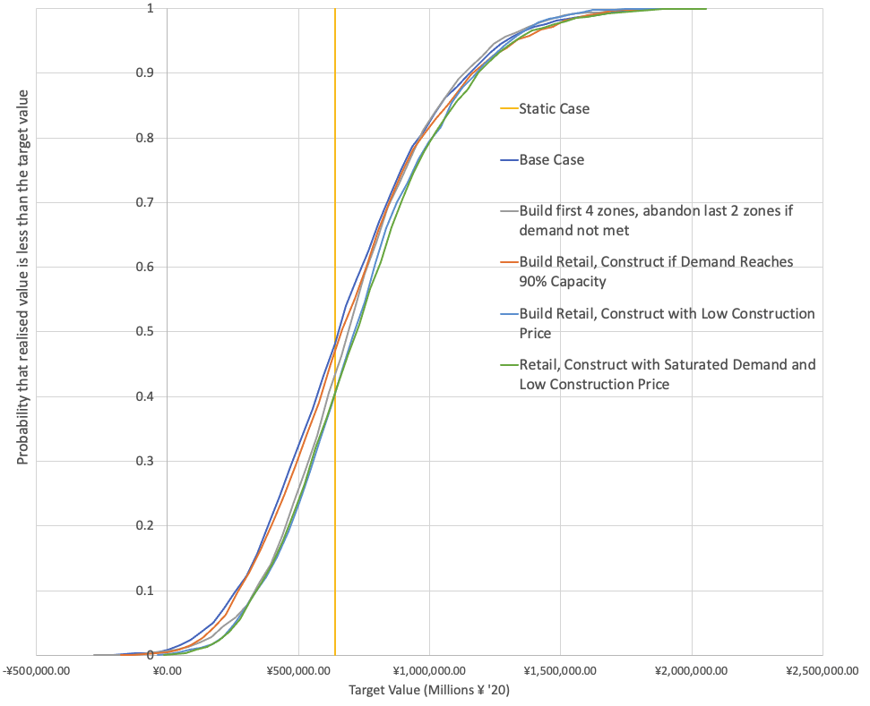
Figure 14: NPV target curves for each flexible case with one-year time-to-build; note that the curves are shifted to the left in comparison to the one-year time-to-build.
Table 7: Statistical parameters for 2-year time-to-build flexibility cases; most advantageous case for each metric is highlighted in green.
Statistical Parameter  (Results in Billion ¥) | Base Case | Build first four zones, abandon last 2 zones if demand not met | Build retail first, construct if demand reaches 90% capacity | Build retail first, construct with low cost of construction | Build retail first, construct with saturated demand and low construction price
Maximum NPV | ¥1,985 | ¥1,909 | ¥1,875 | ¥1,939 | ¥2,011
Minimum NPV | (¥266) | (¥116) | (¥132) | (¥21) | (¥96)
Average NPV | ¥669 | ¥717 | ¥680 | ¥737 | ¥751
Value at Risk, P5 | ¥147 | ¥256 | ¥155 | ¥258 | ¥247
Value at Risk, P10 | ¥239 | ¥339 | ¥278 | ¥338 | ¥350
Value at Gain, P90 | ¥1,112 | ¥1,124 | ¥1,138 | ¥1,179 | ¥1,194
Value at Gain, P95 | ¥1,250 | ¥1,248 | ¥1,269 | ¥1,299 | ¥1,322

Selecting a Flexibility Strategy
The priorities and investments that differing stakeholders have in the project should be considered when deciding to pursue one strategy over another. An important finding through this analysis is that combining flexibilities does not always produce the best outcome for a project. Therefore, a few of the most important general discoveries from the analysis of this real-estate project that are key indicators for selecting an advantageous flexibility strategy are the following:
- Maximize upside by starting with building zones that support retail.
  - When conversion of functions is supported in the modeling approach, it may make sense to convert other allocated space to retail given its profitability.
- Maximize upside by building with condtional functional demand.
  - Currently, if function demand reaches 90% of the current capacity for that function, construction is triggered (up until the max capacity is reached). This 90% condition could be relaxed or tightened given the confidence of future probabilities occurring.
- Minimize downside by enabling possibility for abandonment.
  - Most cases already incorporate abandonment in some form. For instance, if function demand never reaches 90% of capacity, specific zones supporting that function will never begin construction. However, explicitly calling out to stakeholders that abandonment is not only possible, it can actually be a strategic move, is an important decision that the managers can announce in early stages of design.
- Consider the time-to-build variable as a critical decision-ponit.
  - As shown in Section 5.3, the time-to-build variable has dramatic impact on the advantageous nature of each flexibile option. Managers should consider early-on how long they expect construction for each zone to take upon the project beginning.

Limitations and Conclusions

Model Limitations
There are some key assumptions made in this problem, many of which are outlined throughout Section 3, that restrict the scope of analysis and pose relatively signicant limitations. One important assumption is that the ‘capacity’ for all functions – except transportation – are based on spatial quantities. Transportation capacity is estimated given subway occupancy limitations and the rate at which trains operate at the Takanawa Gateway Station. The other functions rely on a per-person occupancy metric for how much ‘space’ they take up to complete the function. For example, a single office-space worker assumes approximately 6.6 m² of space on the site. Given the total area allocated for that function, we can estimate approximately how many people can be supported (at max) on the site for that specific function. This approximation works well for functions such as hotel, office space, and residential space; however, this is not such a good approximation for retail, where each person occupies very different spaces given what they are purchasing and the conditions in which they are purchasing goods. Therefore, it is important to note that the triggers for developing retail are based on less-intuitive capacity constraints. This spatial assumption for capacity could be augmented in the future for functions like retail.

Additionally, the number of floors and the type of space is fixed in this model given the reference architecture described in Section 3.1. However, the agent-based simulator discussed in Section 2.1 accepts a more dynamic architecture input through a user interface decision model. In the future, such a decision tree should be allowed for this model to provide a more flexible approach to changing the parameters of the system more efficiently.

Some other key model and simulation assumptions are that no learning curve or economies of scale are implemented. These important economic variables are largely assumed in other quantities that are already included in the model, primarily in the variability of cost of construction.

Ethical Implications
Given the limitations of the model, there are some key ethical implications of how this analysis can be used to guide management decision-making for this project. For starters, this is a high-level model that can draw broad insights into flexibility decisions – but it should be treated as only one tool in a toolkit to investigate the impact of flexible options. Additionally, currently the sole outcome of the model is NPV of the site over the 15-year time horizon. However, greater economic value may not always produce the best system performance in other dimensions and often can come at odds with other figures of merit. A multi-dimensional flexibility analysis would be the next step in this assessment, where a Pareto frontier could be identified for flexible options along two or more dimensions comparing the performance to NPV output.

Since many of the parameters fielded for this problem come from context-specific sources, such as JR East historical data trends, it should also be noted that model extrapolation to other mixed-use transit hubs should be done with extreme caution. If a new site is desired for mixed-use flexibility analysis, at minimum a new parameter set and reference architecture should be incorporated, including the breakdown of ‘zones’ in the problem formulation.

Overall, one of the greatest findings is that qualitative conclusions are preferred to quantitative conclusions for this project. This is due to the fact that while a first attempt at model validation was made, there is not high confidence in the raw NPV metrics but more so in the general patterns that the flexibility analysis provides. System designers should use this tool to investigate general trends of flexibility and receive general orders of magnitude related to the NPV output rather than quantifying the exact predicted impact of their options.

Lessons Learned

What have you learned through the process of doing the application?
- Flexibility works! It helps improve expected outcome and handles uncertainty well.
- Simulation is an effective tool for evaluating flexibility. Monte carlo simulation works well to capture independent random sampling of the possible uncertainties.
- A well formulated problem helps guide model development and therefore conclusions from the flexibility analysis. However, curiosity as part of human nature tends to mean that model development is an ongoing process as you discover more things to investigate.
- Finding the right conditions to build is an art. It takes time to get to know your system to choose the ‘right’ margins which comprise of the conitional statements for flexibility.
- Beware the flaw of averages!
  - Your cumulative distribution at 50% is not necessarily your average result.
- Designer can often make the decision between considering something an ‘uncertainty’ versus a decision point.
  - An example for this problem: time-to-build could be considered either!
- Excel is extremely powerful! The intuitiveness of Excel makes it an accessible tool for all stakeholders and can perform multiple monte carlo simulations simultaneously.

Where do you see the most use for the flexible approach to design?
- In systems with uncertainty! In general, uncertainty is a part of all engineering systems.
- When economic value is of prime interest.
  - I think that concepts covered in this course, like Economies of Scale, Learning Rate and Discount Rate, impact flexibility a lot – but typically in a way of evaluating profitability. It is harder to extend this approach to purely technical analyses, as liberties may have to be implemented on how to quantify certain measures.
- For large-scale projects where quantitative results can be understood as having wide range of uncertainties. The flexible approach to design is also useful for projects where the qualitative results of analysis can be leveraged aside from the precise quantitive outputs.

Conclusions and Future Work
This real-estate project investigates the impact of construction phasing decisions on NPV of a mixed-use transit hub by incorporating flexible strategies using an Excel-based simulation model which incorporates uncertainties of the system. Flexible strategies like conditional construction for realized function demand reaching near capacity and building when the cost of construction are low are shown to produce advantageous outcomes when compared to the base case. Additionally, the time-to-build parameter is shown to have dramatic impact on the suggested flexible strategies. Stakeholders with varying preferences must collectively determine the best solution for their situation based on their tendencies for risk aversion. Overall, the Takanawa Gateway project is shown to likely be profitable and its economic value can be improved by incorporating flexibility into the phasing decisions of the system design. Future work consists of improving the modeling to enable other flexibilities, such as function conversion or vertical expansion of the site.

Bibliography

[1] | G. Hoy, E. Morrow and A. Shalaby, "Use of agent-based crowd simulation to investigate the performance of large-scale intermodal facilities: Case study of Union Station in Toronto, Ontario, Canada," Transportation Research Record, vol. 2540, no. 1, pp. 20-29, 2016.
[2] | Ministry of Transportation, "Metropolitan Traffic Census: Metropolitan Area Report," March 2017. [Online]. [Accessed 2020].
[3] | Y. Murakami, "JR East's Life-style Business (Shinagawa Development Project)," [Online]. [Accessed 2020].
[4] | East Japan Railway Company, "Takanawa Gateway Station Overview," [Online].
[5] | R. Allan, "Survey of Agent Based Modelling and Simulation Tools," Science and Technology Facilities Council, Warrington, UK, 2010.
[6] | TransferWise, "Japan Real estate: Housing prices overview," 20 May 2019. [Online]. Available: https://transferwise.com/us/blog/japan-real-estate-housing-prices. [Accessed 15 October 2020].
[7] | "What is the Average Sales Price of a Tokyo Apartment?," 31 August 2019. [Online]. Available: https://resources.realestate.co.jp/buy/what-is-the-average-sales-price-of-a-tokyo-apartment-2019-mid-year-update/. [Accessed 15 October 2020].
[8] | S. Cameron, "Business Insider," 20 August 2019. [Online]. Available: https://www.businessinsider.com/airports-spend-more-money-duty-free-shopping-restaurants-2019-8#:~:text=Spending%20in%20airports%20hit%20%2440,and%20%24140%20per%20airport%20visit.. [Accessed 15 October 2020].
[9] | Statistics Bureau of Japan, "Household Income and Expenditure," 1996. [Online]. Available: https://www.stat.go.jp/english/data/zensho/2004/tansin/gaiyo5.html. [Accessed 15 October 2020].
[10] | "Office space estimates along Yamanote Line," [Online]. Available: https://officee.jp/en/price/line/Yamanote+Line/. [Accessed 15 October 2020].
[11] | B. Gaille, "29 Japan Hotel Industry Statistics and Trends," 24 January 2019. [Online]. Available: https://brandongaille.com/29-japan-hotel-industry-statistics-and-trends/. [Accessed 15 October 2020 ].
[12] | Utinokati, "Tokyo Shinagawa-Ku Land Market Value," [Online]. Available: https://utinokati.com/en/details/land-market-value/area/Tokyo-ShinagawaKu/. [Accessed 15 October 2020].
[13] | Japan Property Central, "Okinawa's Construction Costs Exceed National Average," 29 May 2017. [Online]. Available: https://japanpropertycentral.com/2017/05/okinawas-construction-costs-exceed-national-average/#:~:text=In%202016%2C%20the%20average%20construction,average%20of%20197%2C000%20Yen%2Fsqm.. [Accessed 15 October 2020].
[14] | Tokyu Railways, "Takanawa Gateway Station Timetable," [Online]. Available: http://transfer.navitime.biz/tokyu-eng/pc/diagram/TrainDiagram?stCd=00009773&rrCd=00000141&year=2017&month=12&day=31&hour=15&minutes=13&updown=0. [Accessed 15 October 2020].
[15] | Y. Takuma, T. Nishino, N. Ueki and S. Hirano, "Development of 10000 Series Rolling Stock for Tokyo Monorail," 2014. [Online]. Available: http://www.hitachi.com/rev/pdf/2014/r2014_10_104.pdf. [Accessed 15 October 2020].
[16] | "Calculating the Max Capacity of Your Space," 2020. [Online]. Available: https://www.columbus.gov/bzs/document-library/forms/other-forms/Calculating-Capacity-of-a-Space/. [Accessed 15 October 2020].
[17] | "Officee Resources," [Online]. Available: https://officee.jp/en/guide/#:~:text=In%20Japan%2C%20the%20size%20of,1%2D2%20tsubo%20per%20person.. [Accessed 15 October 2020].
[18] | Statista Research Department, "Average area usable per hotel room in Japan from fiscal year 2012 to 2018," 13 October 2020. [Online]. Available: https://www.statista.com/statistics/1053547/japan-average-area-per-room-size-hotels/#:~:text=Average%20area%20usable%20per%20room%20at%20hotels%20in%20Japan%20FY%202012%2D2018&text=In%20fiscal%20year%202018%2C%20the,average%20area%20at%20a%20ryokan.. [Accessed 1 November 2020].
[19] | JR East, "各駅の乗車人員 2019年度," 2019. [Online]. Available: https://www.jreast.co.jp/passenger/index.html. [Accessed 15 October 2020].
[20] | D. Geltner and R. de Neufville, Flexibility and Real Estate Valuation Under Uncertainty: A Practical Guide for Developers, Hoboken, NJ: John Wiley & Sons, 2018.
[21] | R. d. Neufville, Residual Value, 2020.
[22] | East Japan Railway Company, "JRE East Group Report - Integrated Report 2020," Tokyo, 2020.

